

**Differential Equations**

**BS (CS) – 3A, 3B, & 3D**

**Experiment # 5: Variation of Parameter and Cauchy Euler Equations**

**Assigning Date**: January 7, 2021

**Due Date**: January 14, 2021

**Marks**: 5.0

**Submission Criteria**:

1) Complete the handwritten solution by blue pen only on any kind of page.

2) Write your name, registration number, and page number on every page until the last page.

3) Take clear images of solution properly, be conscious about brightness, cropping, etc.

4) Convert all images into the .pdf format.

5) Combined all pdf files sequence-wise.

6) No other format of the document will be accepted for marking.

(A) Describe the reason of variation of parameter method and provide the steps of whole method. (0.6)

(B) Provide the reason to apply Cauchy’s Euler Differential Equations and solve Q # (1, 3, 5, 7, 9, 11, 13). (1.4)

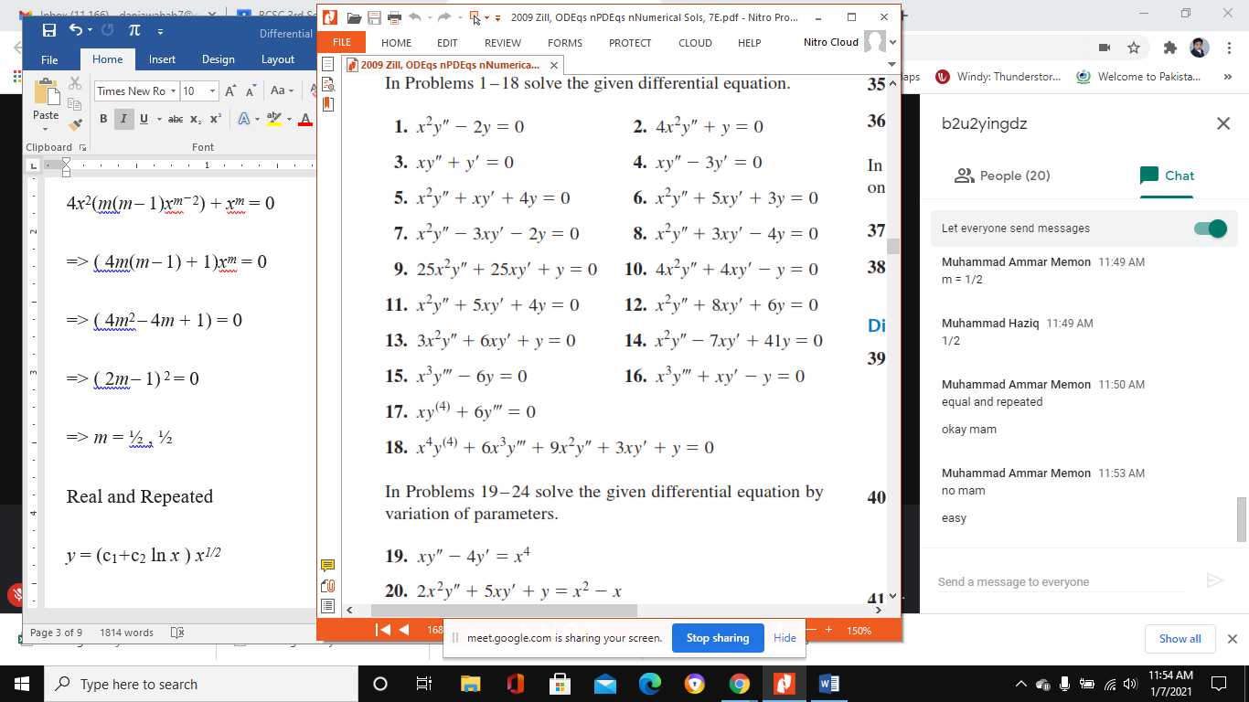

(C) Solve the following differential equation: (3.0)

$$4x^{2}y^{''}+8xy^{'}-3y=7x^{2}-15x^{3}$$